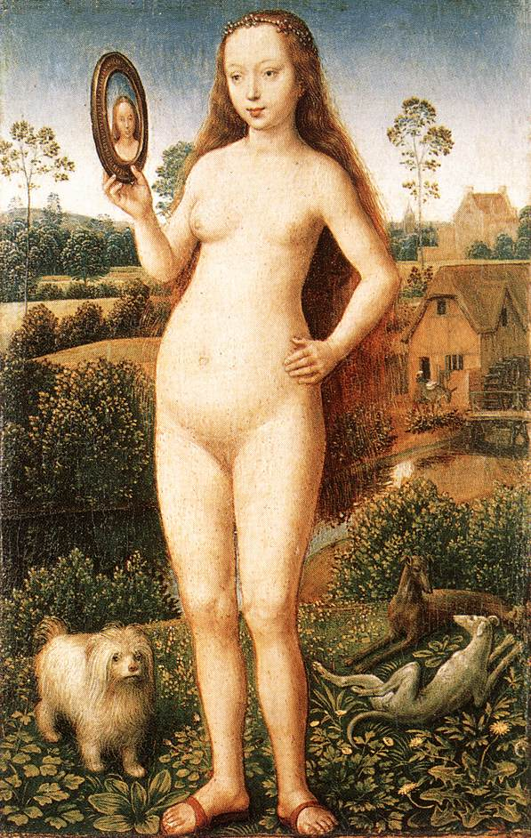
Vanity by Hans Memling
Maya Fenwick, Drawing and Print

“Present a detailed critical analysis, of a cultural text.”

Key Words: Male Gaze, Nude, Vanity, Hypocrisy, Sexualised, 1430, 15th Century, Europe, 1972.

My Visual Artefact for the essay will be a piece called “Vanity” from Hans Memling’s triptych Earthly Vanity made in 1485. I will discuss it through John Berger’s theory of male gaze that he discussed in his “Ways of Seeing” book, published in 1972. I will be using this theory because his views are very pro feminism and as a male writer his writing was ahead of it’s time and carried a lot of weight, whereas a woman with the same opinions in 1972 would not have been given that platform. I also find it interesting how, as a male, he is able to see flaws with male behaviour, which in 1972 was also uncommon. I will also shortly discuss other European paintings during the 15th century to compare the issues stated as a continuous theme in female nude paintings. I am also interest in how feminism throughout the years has changed our mind frames about pieces such as this, and how we are now able to recognise all of the negative aspects of how women were portrayed in and around the 15th century. I will also discuss the ideology surrounding women’s bodies that contributed to this painting, and how it is still deep rooted in today’s society, causing body shaming and confidence issues amongst most women despite feminist efforts.

